iVending Part 2

Project Group 37

Software Requirements

|  |  |
| --- | --- |
| Prepared by: | 1. Vamsitha Chowdary Gude 2. Satya Ajay Kumar Kommineni 3. Sudeep Chowdary Ravipati 4. Sai Chandra Reddy |
| Date: | 12/01/2023 |

* A diagram of a computer

  Description automatically generated with medium confidence**Class Diagram:**

**Fig1: Class Diagram**

* **Sequence Diagrams**

**1. Customer Makes a Purchase**

**2.Customer Views Purchase History**

**3. Employee Restocks Vending Machine**

**4. Distributor Places Order**

**5. Payment Failure and Retry**

**6. Vending Machine Out of Service**

**7. Machine Maintenance Request**

**8. Customer Registers for Loyalty Program**

* **Communication Diagram**

Customer Interfaces

Inventory Management

Operations Center

iVending Machine

Distributors

* **Timing Diagram**

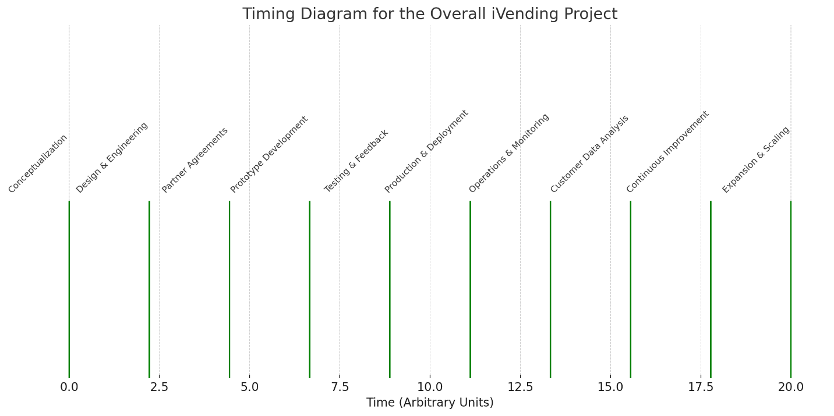

* **User Interfaces**

* **Product Selection Screen:** Displays various food, drink, and snack items, categorized for different meals like breakfast, lunch, and dinner, with clear labels and prices.
* **Payment Screen:** A cashless payment interface with options for card payment, mobile payment, and loyalty program participation. It includes a digital keypad for entering payment details and a prominent 'Pay' button.
* **Machine Monitoring Screen:** Features a dashboard for monitoring the vending machine's status, including alerts for maintenance, inventory levels, and machine performance statistics.
* **State Machine Diagrams**

1. **State Machine Diagram 1:**

1. **State Machine Diagram 2:**

